**Lab 9 Activity 1 – Setting Up a Marks Sheet**

**Objective -** Organize student marks data in a structured table.

1. Open a new Excel workbook.
2. Define column headers: Roll Number, Name, Subject 1, Subject 2, Subject 3, Subject 4, Subject 5, Total, Percentage, Grade.
3. Enter sample student data, ensuring each subject has a maximum of 40 marks.
4. Save the workbook.

__________________________________________________________________________________

**Solutions:**

**Task 1:**

**New Excel Workbook:**

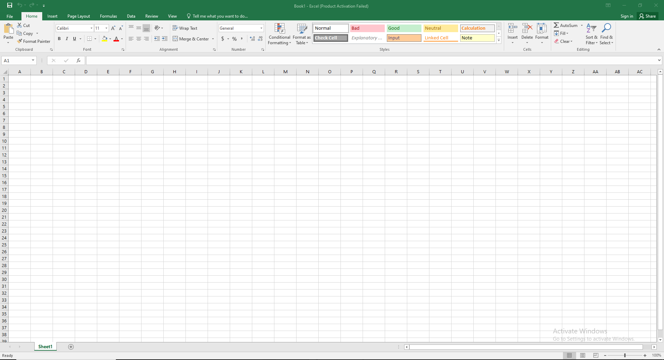

**Task 2:**

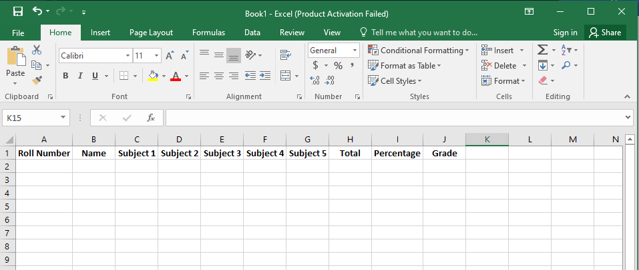• Click on **Cell A1** and type: **Roll Number**

• Click on **Cell B1** and type: **Name**

• Click on **Cell C1** and type: **Subject 1**

• Click on **Cell D1** and type: **Subject 2**

• Click on **Cell E1** and type: **Subject 3**

• Click on **Cell F1** and type: **Subject 4**

• Click on **Cell G1** and type: **Subject 5**

• Click on **Cell H1** and type: **Total**

• Click on **Cell I1** and type: **Percentage**

• Click on **Cell J1** and type: **Grade**

Task 3:

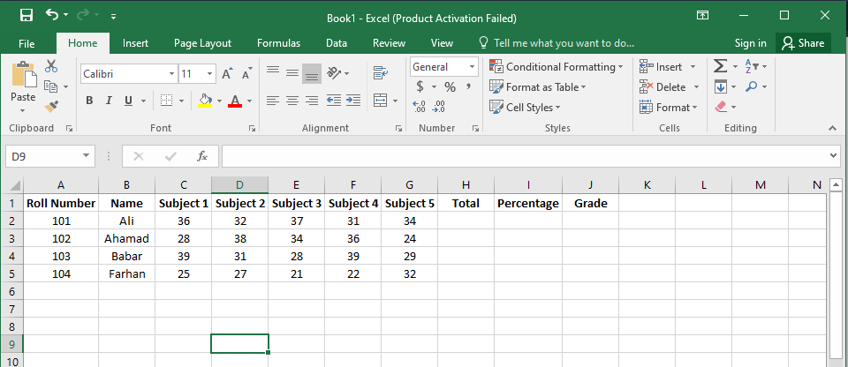

**Task 4:**

• Click **File > Save As**.

• Choose a location and select **Excel Workbook (.xlsx)** format.

• Name it **"Student_Marks.xlsx"** and click **Save**.